Story

Home, not so sweet, home
NA, October 8, 2013 | UPDATED 12:49 IST
I found a really shallow reason to go back to the workplace in my fourth year of stay-at-home mommyhood. I wanted to dress up and go to work. I wanted to change footwear, earrings, wear hair products, lipstick, nail-polish, perfume, cotton saris and silver jewellery.
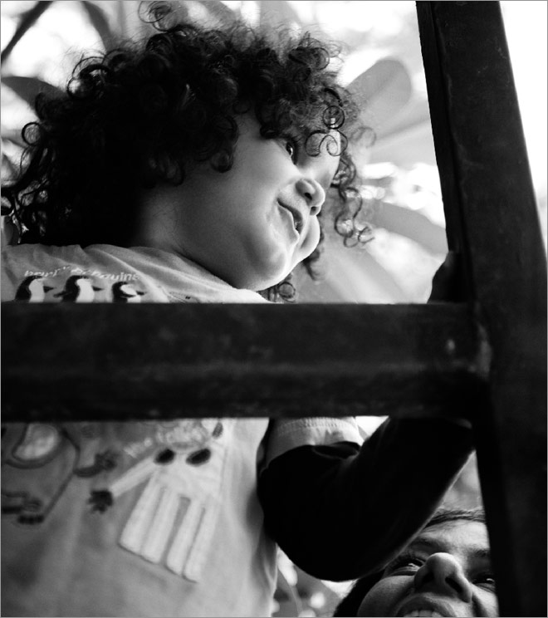
Here's another confession-- When I first quit my good-on-paper job to pursue motherhood four years ago, I had reached the point where I was sapped by the job, by its sameness, by its autopilotness, its rinse-repeatness. Motherhood at that time was like a sizzling affair; it was a start-up; I felt like an entrepreneur. I liked the fact that I could do it by trial and error, that there were no style-guides or briefs, that my baby was a brand I could totally make my own, that it didn't come with excess baggage and that I had no boss! Plus Re, my son, was curly-haired, dimple-chinned and drop-dead-gorgeous.
I was constantly asked "When are you going back to work?" It made me mad. I wrote angsty blogposts. I got hatemail and love-mail in equal measure. I smiled and waved. I had what many women dream of having-unlimited credit. The husband said it was my reward for doing what I was doing. He was lavish with praise, gratitude, money; he fixed me the best drinks after particularly dreary mommy days, he massaged my calves, he always fed the cats, threw out the garbage and made me tea. Sometimes there was a voucher for a dress, sometimes I had a cash-bonus thrown in, sometimes a ticket to Goa; he did his best to keep me incentivised. I had three years in which I could sit around, paint my nails, outsource babyness, buy clothes, go to spas and do pretty much anything for self-indulgence, as long as HE was off baby duty.
I wasted it; I outsourced nothing. I took my job seriously. I treated SAHM-hood like I would a new job. I was always trying to think out of the box, do things differently, wake up every morning and plan meals and things for the day, find ways of making every minute I spent with the boy fun and inspiring. I planned outings, library visits, beach dates, cookie dates, activities, park dates, pot-lucks with much gusto. And one day, I got bored. Really bored. And tired. Really tired. I had decided, though, that the day I felt it was a drudgery, I would stop and try to get back to the work space. I didn't want Re to be at the receiving end of this energy.
The problem with women like me who are awesome with domesticity is that you can begin to think it's a career. Three years later, I hated being a SAHM for the same reasons that I loved it in the first place. That it sucked me out. That it consumed me. That I was so emotionally invested in it that I thought it was me. On most days, I could see the humour in it. I also think children are deep and there's a lot to learn just by listening to them. I found myself laughing and crying in equal measure as I spent hour after hour with my son, just the two of us, and the 'casulls' we constructed, the mess we revelled in. When I got tired of pushing swings in the park, I started mommy-dating. Mommy dates are actually play-dates in disguise.
You make it about the child, because it's legit. But what you are really interested in, is the mother. Will you click, will there be laughs, conversation, wit, sharing, food, travel, sleepovers? So I put myself out there. I lurked. In schools. Parks. Book stores. Twitter. Facebook. I made plenty of "I quit my awesome job because I really wanted to be a stay-at-home-mother" mommy friends. I believed them. I began to say the same thing. It felt good. There is the power of the collective. Blogger mommies. Twitter mommies. Workingfrom-home mommies. School gate mommies. Facebook mommies. Desperately-social-networking mommies. It was important.
Meanwhile every Sandberg, Slaughter, Mayer and Bhagat were holding forth on women in the workplace, constantly making a case for or against SAHMs. It was as if there was a conspiracy to shake women out of their complacency and get them back into the race. Mommies on Twitter were constantly up in arms or really gushy about their words, depending on which side of the fence they sat on. Twitter was full of mommy angst, very cleverly camouflaged to fit a 140 character breeziness. Mommies Instagrammed photos, they wrote micropoetry, they posted link after link (I still don't know whether they actually read all that content). The ones who spoke about the motions and the mundane were termed whine-bags and dismissed. If you had to be cool on Twitter, you had to rise above mommyness. You had to be with-it.
But it still didn't bother me. I was as happy as can be, I reasoned. I had a book deal, a blog, a column, I wrote for various newspapers and magazines, and I ran a well-oiled home. What more could I possibly do? On the face of it, I had it all. But it wasn't enough. It was all too deep. I needed the shallow, the frivolous to feel real. And no, working in PJs is not as much fun as it's made out to be. I realised one thing: It's okay to call your job a drag, but it was not okay to call motherhood a drag. And then I read an article on Slate which truly explained the intensity of what I was feeling in the language of economics. That the marginal utility of time with your kids- the happiness you get from the last hour you spend with them- declines as you spend more hours. Which meant that for nearly everyone, there seems to be at least some decrease in enjoyment as you continue an activity. The same holds for SAHMhood.
I derived my own truth from it-- no one leaves a job that is perfect, that truly makes them happy. Just like no one gives up on a relationship when the sex is really good. The straw that broke the camel's back was being dumped by a mommy on a play-date I had planned for our boys. A mommy I didn't really give a rat's ass about.
It was the beginning of the end. I was done with SAHMhood. It motivated me enough to send out my resume, line up meetings, and announce that I was 'ready'. In less than a month, I had a job. There have been good days and bad days. I have been late for pickups, I have snapped at the husband on the phone, I have run out of meetings like Cinderella, I have got on the wrong train and got so immersed in my book that I didn't notice, I have started dreaming about work. I am shallow enough to think motherhood is about logistics after a point. As long as your plan B and C is in place, you are okay. For now, I want to wake up every morning and GO TO WORK. For now I can pretend to be Rapunzel who has been rescued by a Prince from the tower.
I am liking it. I like swiping my card and hanging out with my team in the canteen. I like the quality time over the quantity time with my son. I like that I have outsourced the dreary bits. And I am no longer afraid to call them dreary. I like me more. I know there should be deeper reasons for going back to the workplace, but for now, this will do.
Lalita Iyer is a journalist and the author of "I'm Pregnant Not Terminally Ill, You Idiot!" Follow her on twitter@Lalitude

Source:India Today,ArchiveSUPPLEMENTS Woman,October 21, 2013
http://indiatoday.intoday.in/story/home-not-so-sweet-home/1/313747.html

